**Step 1: Establish a charter**

Considering the strength of our company in all aspects, we set a charter that articulated our goals and boundary conditions for an innovation effort.

Charter: Create a technology product that focuses on human health and can be launched within one year based on our company's marketing strategy nowadays.

**Step 2: Generate & sense many opportunities**

We focused on both internal and external sources to generate raw opportunities suitable for our company.

Internal:

Our R&D department has developed “Motion-sensing Technology”, which can be applied to detect users’ body conditions. Besides, with the popularization of 5G and big data, it was not only easy for our company to fasten the speed of stable network connection, but also convenient to collect users’ data so as to establish individualized functions.

External:

From the current customers, we learned that they had more demanding for health products because of the pandemic. Then, with the population aging, more elder people meant more needs for diet guidance, so as to deal with the health problem. Besides, many young people who enjoyed advantages brought by technology hoped our company to promote innovative AI product, which could be beneficial to fitness and slow sports injury.

As for other partner companies, we had many cooperation projects with them. With the long-time relationship, our company enjoy more opportunities. First, we could update our new products on Taobao and JD to promote sales. Second, Sf Express could provide logistics support for us to ensure the delivery of our products. Last but not least, we can cooperate with the Keep app, which was one of the biggest exercise apps popular in China, to invite many experts and professional coaches.

**From the above resources, we generated the 4 raw opportunities**:

1. Establish a nutritional diet app, use big data to recommend healthy recipes to users and provide delivery services.

2. Build a smart court, and use motion sensing to guide users' actions in the actual court.

3. Develop an indoor fitness equipment, hire professional trainers and utilize motion sensing technology to allow users to exercise indoors.

4. Develop a smartwatch that monitors the user's heart rate and sleep quality.

**Step 3: Screen opportunities**

Faced with the four raw opportunities, we held a meeting to discuss and voted to choose the products that were more competitive, more worthy of further investigation and more likely to be profitable. **In this step we eliminated the opportunity of developing a smartwatch.**

The result of multi-voting is as follows:

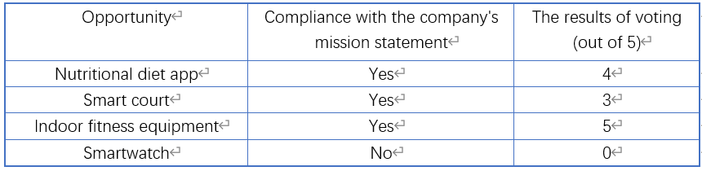

**Step 4: Develop promising opportunities**

In this step, we sought more details about the rest of three opportunities, in order to resolve the greatest uncertainty surrounding each one at the lowest cost in time and money. Our group chose to utilize methods of “Concept generation” and “Customer interviews” to select a few of screened opportunities, which are shown below.

**Concept generation**

1. A nutritional diet app: an APP that uses big data to provide users with healthy recipes and help them properly adjust their diet.
2. a smart court: an APP that can use the motion sensing function to analyze the user's playing movements in the court, provide professional guidance and have social function, which can help users to invite nearby users to play together.
3. An indoor fitness equipment: an AI fitness equipment which can read one's physical indicators while exercising, correct personal posture, provide professional guidance and allow live update interaction.

**Customer interviews**

In order to make our products have better development prospects, we interviewed people around us as well as some experts. We had an envision of what their answers would be, but they still provided lots of unique insights, which are crucial to our final decisions.

When we interviewed our parents, they said they didn't appreciate the function of nutritious meals because they were used to cooking in their own way and didn't trust new food combinations.

At the same time, my classmate said that there are already a lot of ready-made diet collocation recommendations on some social applications, if we invented similar functions of the product, it may be high overlap.

Finally, we consulted our teachers in the school. They said that if a product only has the function of nutritious diet, it is too simple and has poor development prospect in the constantly changing market, it is not convenient to cooperate with other companies as well.

After reviewing those above interviews, **we decided not to develop a product related to the nutritional diet field**.

**Step 5: Select exceptional opportunities**

In this part, we used “Real-Win-Wirth-it” to select the opportunity that is most worthy of investment. The following charts show the RWW criteria applied to the “an AI fitness equipment” opportunity. **In this step we selected an exceptional product opportunity: Develop an indoor fitness equipment.**

1. Is the opportunity real?

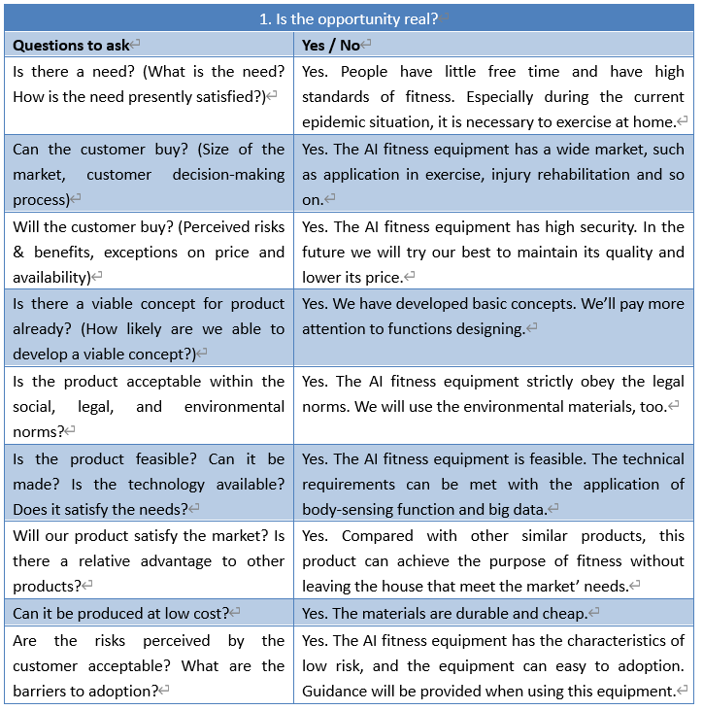

2. Can you win with this opportunity?

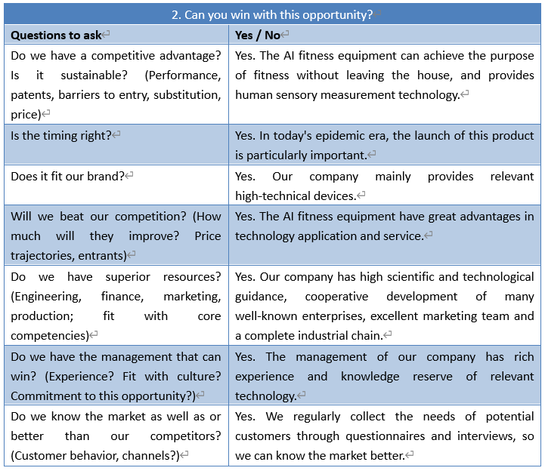

3. Is it worth doing?

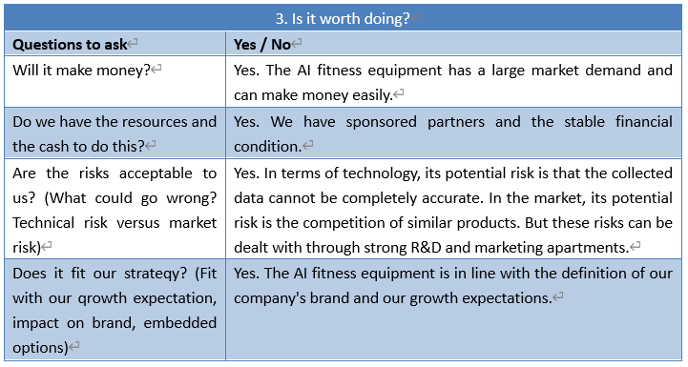

**Step 6: Reflect on the results and the process**

Timely reflection can not only let us know the existing problems, but also help us improve the work efficiency in the next stage.

After reflection, we found that the opportunities we found were viable. First, our team considered dozens of opportunities from internal and external sources. Second, the innovation charter clearly stated the purpose of the organization and its focus was not narrow, so we had more opportunities than we expected. Third, our filtering criteria were objective, which was based on the possibility that the eventual product would be produced successfully. Therefore, the resulting opportunities excited to the whole team.